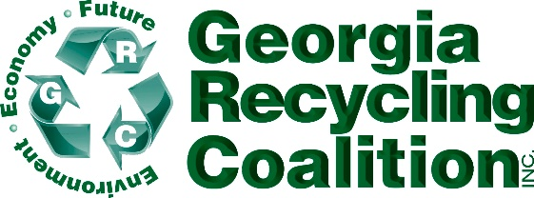
GRC ANNUAL MEMBERSHIP MEETING
September 27, 2022 8:30-9:30 AM
King & Prince, St. Simons Island, GA

8:30 CALL TO ORDER Jeff Lipscomb GRC 2022 President
8:30 MINUTES-2021 Annual Meeting Susan Wood, GRC 2022 Secretary
8:35 TREASURER REPORT Chris Witherspoon, GRC 2022 Treasurer
8:40 EXEC.DIRECTOR REPORT Gloria Hardegree
Recognition of Sponsors/Burns Scholarship Award
8:45 COMMITTEE REPORTS:
Membership Kimberly White/Page Beckwith
Program Beyonca Padgett/Abbey Patterson
Education Stephanie Busch/Susan Wood
Communications Mason Towe/Scott Terrell
9:05 ELECTION OF BOARD POSITIONS for 2023-2025 Term
9:10 Special Reports
Sarah Knapp, GA EPD-MMP & RWD/SWTF Grants
9:30 ADJOURN
CALENDAR-2022

October 18-20, 2022 Paper/Plastics (pprc+) Conference Chicago, IL

October 25-27, 2022 SERDC Summit Charlotte, NC

November 14-16, 2022 SWANA GA CHAPTER Fall Conf. Sea Palms
St Simons Island, GA
November 15, 2022 America Recycles Day

